**電通三乙微處理器實驗 實驗結報**

|  |  |  |  |
| --- | --- | --- | --- |
| **實驗名稱** | **Lab03-類比輸入** | | |
| **組別** |  | **組員** | **05052446 李嘉誠** |

1. **實驗目的**

**使用USB-Serial做輸入輸出**

**讀取類比輸入脂數值**

1. **量測0/0.5/1.5/2/2.5之電壓直**
2. **量測可變電阻之數值**
3. **量測光敏電阻之數值**
4. **實驗步驟**

**1.由Arduino傳送訊息給PC**

**Arduino傳送一訊息”Heiio,World!”至PC**

**2.PC經由Serial Monitor接收**

**打開Arduino IDE的Serial Monitor,確認有收到訊息**

**3.由PC傳送至Arduino**

**傳送命令1及0至Arduino**

**Arduino收到’1’後,LED7亮**

**Arduino收到’0’後,LED7滅**

1. **程式碼**

**const byte ledPin =12;**

**void setup()**

**{**

**Serial.begin(9600);**

**Serial.println("Hello,");**

**Serial.print("\tLED pin is:");**

**Serial.print("LedPin");**

**Serial.print("\nBYE!");**

**}**

**void loop(){**

**byte val;**

**if(Serial.available())**

**{**

**val =Serial.read();**

**if(val=='1')**

**{**

**digitalWrite(ledPin,HIGH);**

**Serial.println("LED ON");**

**}**

**else if(val =='0')**

**{**

**digitalWrite(ledPin,LOW);**

**Serial.println("LED OFF");**

**}**

**}**

**}**

1. **實驗結果及分析**

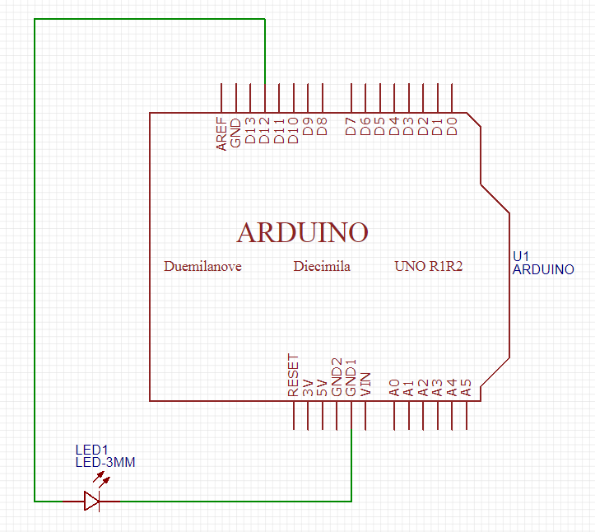

|  |  |  |
| --- | --- | --- |
| **PC輸入** | **SerialMonitor** | **LED狀態** |
| **0** |  | **滅** |
| **1** |  | **亮** |

1. **心得討論**

**這次實驗分析比較多,有比上次的還要難一點,但多練習就會慢慢習慣,慢慢就會融會貫通,下次繼續努力**

1. **修正電路圖**

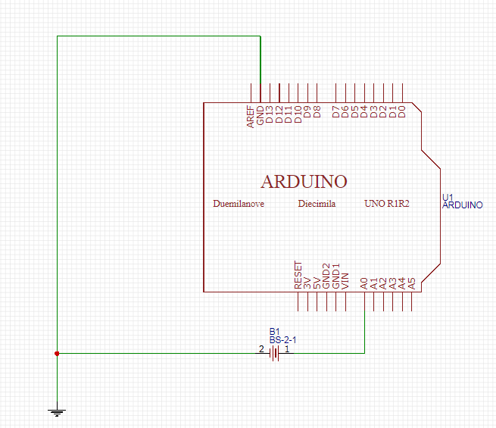

**修正程式碼**

**float Analogin = 0;**

**float k;**

**void setup(){**

**Serial.begin(9600);**

**pinMode(14,INPUT);**

**}**

**void loop(){**

**for (int i=0;i<=5;i++)**

**Analogin = 0.7* Analogin + 0.3* analogRead(14);**

**k =(Analogin * 2.5) / 4095;**

**Serial.println(Analogin);**

**Serial.println(k);**

**delay(500);**

**}**

**實驗結果及分析**

|  |  |  |  |
| --- | --- | --- | --- |
| **實際電壓(V)** | **AnalogRead讀值** | **推測電壓(V)** |  |
| **0** | **9.5** | **0.00 V** |  |
| **0.5** | **834.31** | **0.51 V** |  |
| **1** | **1659.33** | **1.01 V** |  |
| **1.5** | **2478.09** | **1.51 V** |  |
| **2** | **3318.19** | **2.02 V** |  |
| **2.5** | **4095** | **2.5 V** |  |

1. **修正電路圖**

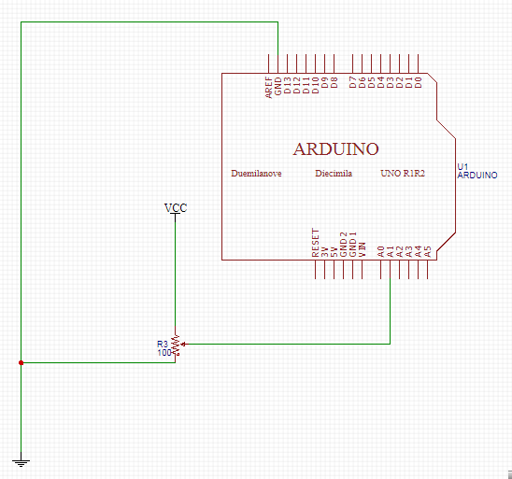

**修正程式碼**

**float sensorValue=0;**

**float sensorVoltage;**

**float Vin=5;**

**float R=1000000;**

**float R1;**

**float R2;**

**float val;**

**void setup()**

**{**

**Serial.begin(9600);**

**pinMode(15,OUTPUT);**

**}**

**void loop(){**

**int i;**

**for (i=0;i<=5;i++)**

**sensorValue = 0.7* sensorValue + 0.3* analogRead(15);**

**sensorVoltage = sensorValue * 5 / 4095;**

**R1 = sensorVoltage * R / Vin;**

**R2=R-R1;**

**sensorVoltage= (Vin * R1) / R;**

**val=analogRead(15);**

**Serial.print("analogRead=");**

**Serial.print(val);**

**Serial.print("\tsensorVoltage=");**

**Serial.print(sensorVoltage );**

**Serial.print("\tR=");**

**Serial.print(R);**

**Serial.print("\tR1=");**

**Serial.print(R1);**

**Serial.print("\tR2=");**

**Serial.println(R2);**

**delay(500);**

**}**

**實驗結果及分析**

|  |  |  |  |  |
| --- | --- | --- | --- | --- |
| **可變電阻量測值** | **AnalogRead讀值** | **堆測電壓** | **推測電阻** | **SerialMonitor輸出** |
| **1K**Ω | **9.00** | **0.01 V** | **2228Ω** |  |
| **100K**Ω | **424** | **0.5 V** | **106459**Ω |  |
| **200K**Ω | **812** | **1.01 V** | **201743**Ω |  |
| **300K**Ω | **1263** | **1.51 V** | **301782**Ω |  |
| **400K**Ω | **1640** | **2.02 V** | **403498**Ω |  |
| **1M**Ω | **4095** | **5.0V** | **999999.88**Ω |  |

**8.修正電路圖**

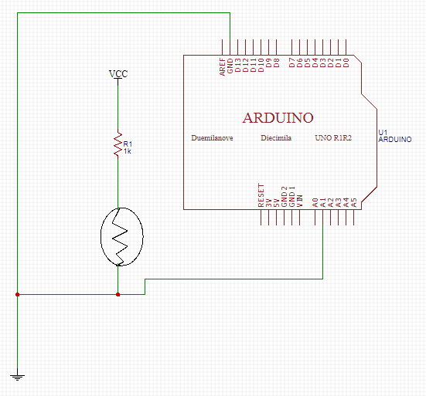

**修正程式碼**

**float sensorValue=0;**

**float sensorVoltage;**

**float R=5000000;**

**float R1;**

**float val;**

**void setup()**

**{**

**Serial.begin(9600);**

**pinMode(15,OUTPUT);**

**}**

**void loop(){**

**int i;**

**for (i=0;i<=5;i++)**

**sensorValue = 0.7* sensorValue + 0.3* analogRead(15);**

**sensorVoltage = sensorValue * 2.5 / 4095;**

**R1 = sensorVoltage * R / 2.5;**

**val=analogRead(15);**

**Serial.print("analogRead=");**

**Serial.print(val);**

**Serial.print("\tsensorVoltage=");**

**Serial.print(sensorVoltage );**

**Serial.print("\tR1=");**

**Serial.println(R1);**

**delay(500);**

**}**

**實驗結果及分析**

|  |  |  |  |
| --- | --- | --- | --- |
| **AnalogRead讀值** | **推測電壓** | **推測電阻值** | **SerialMonitor輸出** |
| **4095** | **2.5V** | **4999999.50**Ω |  |
| **2772** | **1.67V** | **3337075.75**Ω |  |
| **1137** | **0.68V** | **1368740.00**Ω |  |